CALIFORNIA LICENSED FORESTERS ASSOCIATION
BOARD OF DIRECTORS MEETING
Tuesday, October 19, 2021 - 6:00 PM

Board Minutes

Jason Wells called the meeting to order at 6:05 pm.

Members present: Jeremy Wright, George Gentry, Mark Pugsley, Ariel Roughton, Charll Stoneman, Ricky Shurtz & Bob Broderick

Member’s not present: Joe Starr & Matt Bissell

Others present: Kathleen Burr, Andrea Eggleton

Charll Stoneman moved with a second by Mark Pugsley to approve the agenda.

George Gentry moved with a second by Charll Stoneman to approve the September Board minutes. Motion passed unanimously.

Treasurer’s Report – Kathleen Burr &, Mark Pugsley reported:
- Profit & Loss – Net Income $13,987.02
- Balance Sheet – Total Assets $315,281.03
- Budget vs. Actual:
  - Income – 82.36% of budget
  - Expenses – 73.91% of budget
- Managed Accounts:
  - Archaeology - $33,335.96
  - CLFA Scholarship - $31,500.28
  - Roy Richards - $10,806.62
  - Hazel Jackson - $6,648.69

George Gentry moved with a second by Jeremy Wright to approve the financials as presented. Motion passed unanimously.

Executive Directors report & Archaeology classes – Kathleen Burr reported:
- Kathleen is working on the 2021/2022 budget that will be sent to Mark and the Executive Committee.
- Final bills are not in on the October 5-day archaeology class.
- Kathleen discussed with Len Nielson the need to raise the cost of the 5-day due to the increase in costs with outside instructors – mainly Beth Bagwell. This probably will not happen until 2023.
- Kathleen discussed with Len the ongoing topic of having a CLFA member teach a portion of the archaeology classes. Len will be meeting with the Cal Fire teaching cadre to discuss again. Len did not feel CLFA should be in attendance.
- March 2022 class is completely full and the October class is 1/3 full.
- Len discussed holding a class in Southern California in 2023.
- Final numbers for archaeology will be complete in November.
- Bob Broderick mentioned there is a Cal Fire training center in Ione.
- Kathleen discussed the loss in the archaeology account last year and there will be another one this year.
- Credit card fees – Kathleen would like the Board to discontinue covering credit card fees.
Correspondence: None received.

New Members:
- Sara Groban – Student
- Zoey Cardoza – Student
- Jacob Pass – Student
- Cameron Tavis – Student
- Joshua Zastrow – Student
- Thomas Franaszek – Student
- Josh Frankiewicz – Student

Ricky Shurtz moved with a second by Charll Stoneman to approve the new student members. Motion passed unanimously

Board of Forestry: Andrea Eggleton reported:
- Board of Forestry is looking for a new Executive Officer.
- The Board of Forestry met the day after the October meeting.
- Numerous presentations were made to the Board on wood products innovation – bio fuels, barriers to mass timbers, and cross laminated timber.
- Not much was covered that would be in the direct interest of CLFA.
- Charll brought up the topic of “teathered logging vs. cable-tractor option logging” which Cal Fire questioned. YG questioned the Board – there seems to be two conflicting conditions – tractor operations on cable is ok and another point says no. The Board resolved by saying “no cable with tractor options”. YG felt the Board should have kept teathered as a separate section from cable & tractor. Tractor with cable options works fine – the other way around was mis-interrupted. It was in unintended consequence. The Board will work with plan submitters to resolve.
- Andrea received an article about the debris removal occurring in the Dixie Fire. A workshop was held by Plumas County and Cal OES – it was explained to folks attending that part of the process would be having a certified arborist assess the trees on the parcel. An RPF contacted Andrea with concern that an RPF cannot bid on these projects with Cal OES as they are using arborists. Ricky Shurtz informed the Board that funding is coming down from FEMA and federal government. They only approve these trees by a certified arborist. The RPF oversees and the arborist is marking the trees. Bob Broderick said that different regions appear to have different rules due to the severity of the fire regions.
  - Jason Wells noted that we should reach out to the state and Cal OES that RPFs should have the opportunity to bid on these tree assessment projects.

Education
- Jason Wells reached out to Jon Anderson at Humboldt Redwood Company & Ricky reached out to Mike Smith owner of Unity Forest Products to discuss holding two brown bag tours – one at each location. The topic will be log scaling and mill tours. Dates selected will be confirmed.
  - December 3, 2021 – Unity Forest Products
  - December 10, 2021 – Humboldt Redwood Company

Outreach – Jeremy Wright – nothing new to report

Legislation –
- SB709 – THP Extension Bill – signed last week.
- AB1346 – Small engine emissions – signed - how will the air resources board implement the regulations? Chain saws will be problematic. This bill was not intended to be directed at rural folks, but intended for urban areas, but there was no way of parsing the specific language out

Licensing – George Gentry reported:

Water & Wildlife – Mark Pugsley reported:
- In response to Gov. Newsome’s Statewide Drought Emergency declaration the state Water Control Board has begun the process of curtailing junior Water Rights from some of major watersheds
- The Division of Water Rights is temporarily suspending all curtailments in the Lower Russian River Watershed, effective 12:00 am, Thursday, October 21, 2021, and all curtailments in the Upper Russian River Watershed, effective 12:00 pm, Saturday, October 23, 2021. Temporary curtailment suspensions are likely to last until at least November 1st.
- Shasta River- Some curtailment orders have been temporarily suspended this order will be suspended 10/31 unless 125 cfs minimal flow is recorded at the Yreka gauge
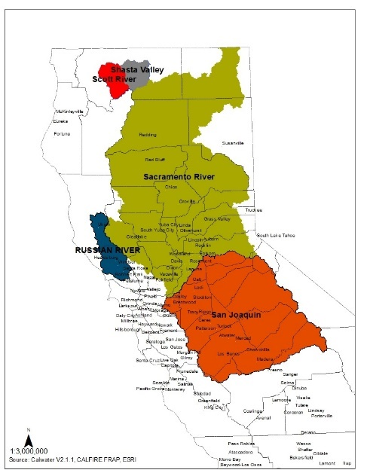

California Fish and Game Commission:
- Cascade frog (Rana cascadae) - The one-year status review report for the petition to list this species as Threatened or Endangered under the California Endangered Species Act. Staff will recommend that this item be continued at a future meeting.
- Upper Klamath-Trinity River spring Chinook salmon- Consider ratifying findings on the decision to list upper Klamath-Trinity River spring Chinook salmon (Oncorhynchus tshawytscha) as threatened under CESA. Staff will recommend that this item be continued to a future meeting.
- Northern California summer steelhead -Consider ratifying findings on the decision to list northern California summer steelhead (Oncorhynchus mykiss irideus) as endangered under CESA. Staff will recommend that this item be continued to a future meeting.
Communications – Jason Wells reported:
- Website was down for a few days. Domaine expired and we did not have the correct log-in information. Kathleen paid for five years. We do not know where the email for renewal was sent and the answers to the security questions. Seems not to have affected the membership.
- YG is pulling together historical documents and creating a Google drive file. YG will send Jason Wells the link to review. Jason felt this would be a good benefit for our membership.
- Kathleen discussed how the board would like the “invitation to members to join the board meeting” be worded each month. A specific invitation resulted in quite a few members joining a meeting. Just sending out a reminder has resulted in no one attending.

Charll offered to become the Chair of the Forest Practice Committee.

Scholarships – Charll Stoneman reported:
- Charll revised the scholarship questions to be more generic and they have been sent out for both CLFA and Roy Richards.
- Howard Biswell Scholarship – Charll recommends this scholarship should be sent out with a deadline the end of April. The solicitation would be through Diane Dealey Neill and to junior colleges.

Newsletter articles are due to Kathleen October 25, 2021.

November board meeting will be held at Granzellas in person.

Respectfully submitted,

Kathleen Burr
Executive Director

